(To be drafted on Rs. 100 stamp paper & signatures of the authorized signatory to be attested by bank)

INDEMNITY BOND
(For factory destuffing)

To,
Yang Ming Line (India) Pvt. Ltd.,
3E,3rd Floor, Uppals M6 Plaza,
Plot No.6, Jasola District Centre, Jasola,
New Delhi- 110 025
Ph: +91 11 46888800, Fax: 46888811

RE: FACTORY DESTUFFING INDEMNITY BOND FOR ALL
CONTAINERS ARRIVED AT NORTH INDIA ICD’S VIA GATEWAY PORT NHAVA SHEVA/MUNDRA/PIPAVAV ON ACCOUNT
M/S………………………………………………………………………………………………….

Dear Sirs,

Sub: M.V. _________________ VOY. ___________
IGM no. ______________ dated _____________
MBL No. ____________
Container No/s. ____________________________________

Whereas for the purpose of destuffing the cargo we the forwarder/consignee M/s………………………… wish to remove the import laden Container/s from Inland container Depot………/Nominated area…………../Port premises to our factory/warehouse situated at:

_________________________________________________________________________

We as receivers/Consignees are executing this indemnity bond in favor of “Yang Ming Line (I) Pvt Ltd.” to ensure safe return of the containers within stipulated period of time. We undertake to bear the entire cost of transportation and handling charges for the said container/s from the time of picking up the laden container/s from______________________ to our premises till the time of delivery of empty container to the yard nominated / designated by you.

Now therefore in consideration of your allowing us to take container out for destuffing at our site, and also in consideration of your having executed a Bond with the Customs vide Bond No( S/43-CONT (B) NS/165/2022, to Jawaharlal Nehru Customs House;/ CB/196/2021 to Mundra Custom House;/ GEN/33/21-22/CB/GPPL to Pipavav Custom House) , undertaking the re-export of the containers within the period stipulated by Customs, we, the undersigned hereby undertake and guarantee the following.

(We, M/s.______________________, the forwarder/consignee, agree and undertake for ourselves, our successors and assignees to indemnify you, your servants and agents and to hold all of you harmless in respect of any liability, loss or damage, demands and costs of whatsoever nature whether direct or indirect which you may sustain while containers are in our custody.
This indemnity in force is in addition to standard terms and conditions of bill of lading and its contractual obligations, responsibilities and liabilities binding on merchant including shipper and consignee.

We hereby agree and confirm to abide by the following terms and conditions:

1. We, the forwarder/consignee shall take all responsibilities and care to ensure that the container/s are handled and returned in safe, sound and seaworthy condition by all whose acts of omission and commission, the forwarder/consignee are solely liable.

2. We the forwarder/consignee undertake to indemnify the carrier and/or their agents above named against all damages / losses / liability/ third party liability cost or expenditure suffered or incurred by the movement of container while in possession of the importer, including injury or death of person or loss or damage to property or other person in the process of such movement and destuffing operation.

3. We shall return the container in good/sound condition at the Line’s nominated Empty Return Location mentioned on Delivery Order / Empty off-loading letter or any other similar document within validity period. For this purpose, survey conducted by your authorized surveyor and their reports and findings and their fees thereof shall be binding on us. For any kind of damages caused
to the containers while in our possession due to any willful act, negligence by us/our appointed agency or by any third party, other than natural wear and tear, the Repair Cost estimate or the Debit given by you in case of total loss, will be accepted as final and binding on us and paid and reimbursed by us instantly.

4. The forwarder/consignee indemnify the carrier or the agent for any claim by you/Shipping Line and/or Customs to the extent of container value as under: -

SIZE | TYPE | CONTAINER VALUE IN USD
20' | DRY STANDARD CONTAINER | 4650
40' | DRY STANDARD CONTAINER | 7500
40' | HIGH CUBE CONTAINER | 8000
45' | HIGH CUBE CONTAINER | 9500
20' | REEFER | 20900
40' | REEFER HIGH CUBE | 26000
20' | OPEN TOP | 5300
40' | FULL HIGH OPEN TOP | 7750
20' | FLAT RACK | 11650
40' | FULL HIGH FLAT RACK | 11650

In case of total loss, the applicable customs duty or any other charges for total loss of container on and above the value of container shall be payable by forwarder/consignee. This will also cover cases where consignee or his appointed CHA or transporter fail to return the container to the Line’s nominated Empty Return Location within Delivery Order validity.

5. The forwarder/consignee shall be liable for container detention after the five free days / Free time mentioned in the Service Contract, from the day the laden import container arrived at the Inland Container Depot / Port premises till the day the empty container/s returned back to Inland container depot / empty storage yard after factory de-stuffing, as per the applicable Line tariff at the time of discharge. In case, forwarder/consignee fail to return the empty container/s within stipulated period, then they shall revalidate the DO/Factory permission after payment of applicable detention charges. Detention will be charged as per below tariff; & same is also available on YMI website www.yangming.com/india for latest detention tariff.

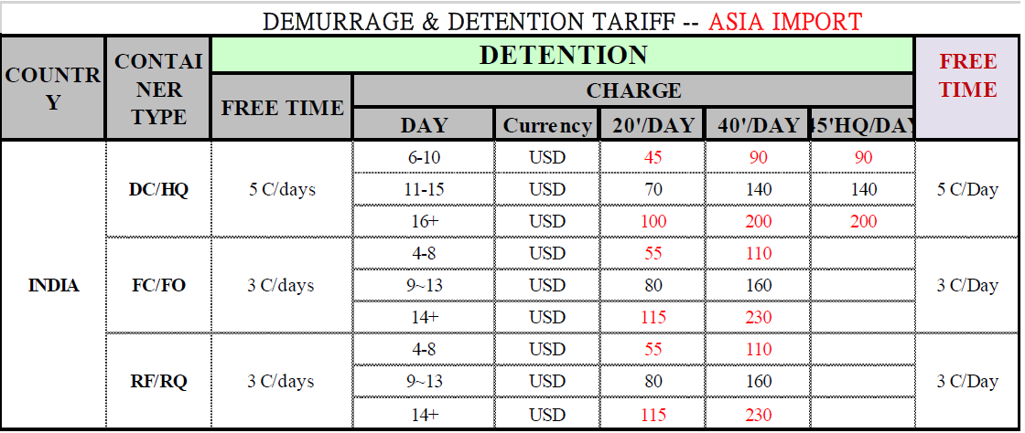

6. The forwarder/Consignee agrees to return the container in good order and Sound condition at the storage yard designated by YANG MING LINE (INDIA) PVT.LTD within the period of validity in the delivery order. The importer is liable to pay detention in case of any delay, then till the date the container/s are returned to inland container depot/nominated area/empty storage yard.

7. For any charges becoming due to you on account of damage to containers, loss, third party liability or detention on container, we authorize you to debit our account and adjust against any security amount or any other amount lying with you in any other capacity or impose lien over any cargo or material in your possession belonging to us till such time the amount due to you is realized completely.

8. The Importer will ensure that any claims made towards outstanding detention will be paid within 7 days of claim made by the Line according to the published tariff. Similarly, any damage claims made will be settled on next working day on provision of reports and photographs.

9. The forwarder/consignee hereby confirm that the import cargo does not contain any contraband and articles in terms of Indian Customs Regulations and that the shippers have not tampered with the cargo for the purpose of concealment of any contraband cargo and would be responsible for all costs and consequences for the same.

10. To the extent of the Undertaking and declarations herein and to the extent of the loss and/or damage caused arising out of breach thereof or any consequential or indirect losses/damages caused in respect or furtherance thereof and to the extent of any claims, litigations, damages, expenses and costs as suffered or may be suffered by the carrier/agents by way of noncompliance of any of the undertakings covenants herein or generally any other acts/care/cautions as should have been done and have not been done or cautions as should we been observed and has not been observed or arising out of any of our act or failure to act as a prudent person would do we, subject to the monetary limitation herein agree to indemnify and keep the carrier/agent indemnified.

11. Disputes, if any, will be subject to jurisdiction of courts having territorial jurisdiction over your principal working office.

12. In case, Customs levy on you any duty/fine/penalty due to total loss to the container/s or failing to return the container within the requested time limit, we are jointly or severally liable and accountable for said loss and will compensate to Yang Ming Line (India) Pvt. Ltd. the same on demand.

13. This document is valid till the date of the return of the last container to the carrier’s nominated CY/ICD facility.

Consignee Stamp & Signature
(Name of authorized person signing with designation,
name & address of the firm)

DATED: _____________________
PLACE: _____________________
_____________________

(Signature attestation by bank)

